**Advanced Joins or Intelligent Joins**

**Considers Employees (tblEmployee) and Departments (tblDepartment) tables**   
  
**Employee Table (tblEmployee)**  
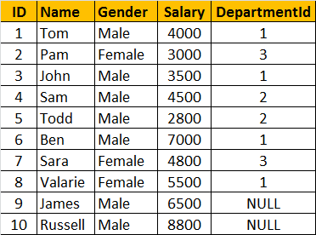 

**Departments Table (tblDepartment)**  
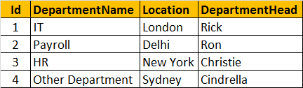

**How to retrieve only the non-matching rows from the left table.**

**The output should be as shown below:**   
http://1.bp.blogspot.com/-7vt-QpC4mZ8/UDDiiSTHcUI/AAAAAAAAAPo/5x1-GB7B9VM/s1600/Only+Left+Table+Rows.png   
  
**Query:**  
SELECT       Name, Gender, Salary, DepartmentName  
FROM           tblEmployee E  
LEFT JOIN   tblDepartment D  
ON                 E.DepartmentId = D.Id  
WHERE        D.Id IS NULL  
  
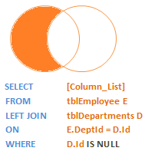   
  
**How to retrieve only the non-matching rows from the right table**  
http://1.bp.blogspot.com/-ycu3SCB-mn0/UDDj12WVhYI/AAAAAAAAAP4/WoJn5XGOlJc/s1600/Only+Right+Table+Rows.png   
  
**Query:**  
SELECT         Name, Gender, Salary, DepartmentName  
FROM             tblEmployee E  
RIGHT JOIN    tblDepartment D  
ON                   E.DepartmentId = D.Id  
WHERE          E.DepartmentId IS NULL   
  
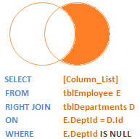   
  
**How to retrieve only the non-matching rows from both the left and right table. Matching rows should be eliminated.**   
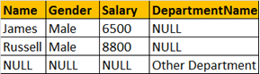  
  
**Query:**  
SELECT         Name, Gender, Salary, DepartmentName  
FROM              tblEmployee E  
FULL JOIN      tblDepartment D  
ON                   E.DepartmentId = D.Id  
WHERE          E.DepartmentId IS NULL  
OR                   D.Id IS NULL  
  
